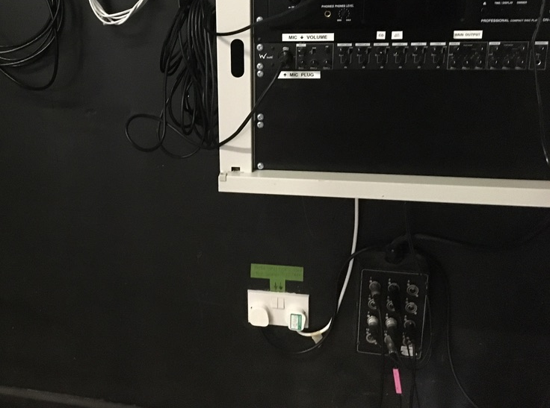
These instructions refer to the audio system located on the stage, to the right side looking from the hall. It feeds 4 speakers in the hall

- Switch on BOTH Plugs at the twin socket low down on the wall. SWITCH OFF BOTH BEFORE YOU LEAVE

- To play a CD, press the small on/off button on the control panel marked “CD” – a green indicator light comes on. On the DENON CD player, use the Eject, play and fast forward etc buttons as per a normal CD player.
Turn the small knob marked “CD”, adjacent to the CD on/off button to control the volume.
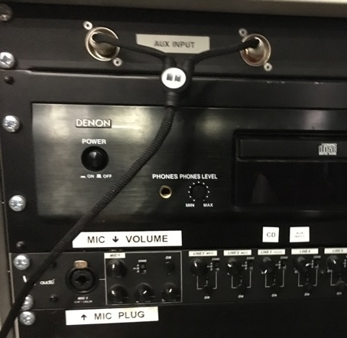
- To play an Auxiliary (AUX) Device e.g. Smart Phone, iPod or sound via a
Laptop or TV, press the small on/off button on the control panel marked “AUX” – a green indicator light comes on.
Connect via the 3.5mm jack on your device into the trailing lead provided, which is already plugged into the front panel of the control panel marked AUX INPUT, plus the provided extension lead if necessary.
Turn the small knob adjacent to the AUX on/off button to control the volume.

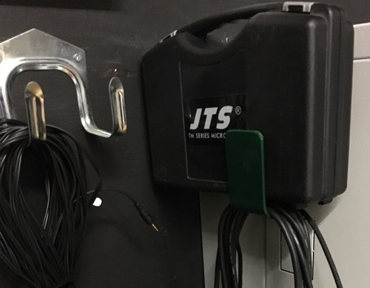
4. To use the microphone (mic) - it is stored in its own box located on top of the control panel. Its cable hangs coiled on the bracket on the left-hand end of the control panel.
Plug in the mic to its cable and the mic cable to the socket on the control panel adjacent to the label “MIC Plug”. Press the small “ON” button to energise the MIC – a green light comes on.
Switch on the on/off slider on the mic.
Turn the small knob marked “MIC 1”, next to the MIC on/off button to control vol.

The plug sockets wall-mounted above the control panel refer to the overhead projector, not the audio system.
Do not unplug any other cables or change any settings in the back of the control panel or adjacent to it

