These instructions refer to the overhead projector mounted on the lighting rail in the main hall. Instructions for operating the motorised screen are mounted on the opposite wall (to the left behind the stage) also on line via rowneygreen.org
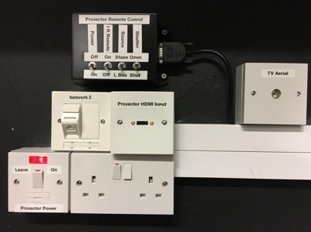
- Plug in an ethernet cable, which connects to your chosen input device (laptop or set-top box). Note that WiFi is also available “RG Village Hall” – WEP password “F2HYNPX5VVTT”

2. Check the neon light on the projector power supply is on. If not, switch it on

3. Plug in an HDMI lead, to your chosen input device (laptop, set-top box or e.g. Apple TV)

4. Plug in a suitably long coaxial TV lead if a set top box is to be used
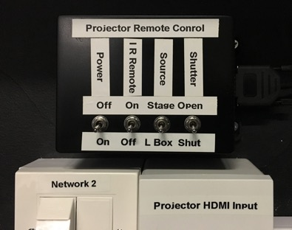
5. Switch “Power On” to start the projector (red neon on the front of the projector will turn green but it takes some minutes to warm up

6. Select IR Remote “Off” (IR “On” only used for set up by technicians)

7. Select “Source Stage” (select “L Box” only when content is being played from the upstairs “Lighting Box” control room)

8. If during e.g. a slide show, you wish to temporarily kill the projector image and sound, select “Shutter Shut”, otherwise leave it set to “Open”.
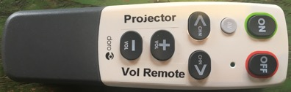
9. Volume can be controlled 2 ways:
9.1 Point the remote towards the projector and use + and – buttons. (Other buttons are not operational)
9.2 Using laptop or set-top box vol. controls by plugging into the “aux input” of the audio system via a 3.5mm jack plug – see also Stage-Side Audio instructions
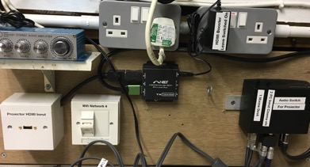
10. A laptop can also be used in the upstairs (lighting box) control room. On the control box behind the stage, switch Source to “L Box” but set all other controls as instructed above. Use either the Projector Vol. Remote or plug the grey lead with 3.5mm jack into the laptop for controlling sound via the laptop’s volume control

11. To shut down, ensure “IR Remote” switch is set to “off”. On the black box, switch “Power” to “off”. The projector will enter a cooling phase. When its green light turns to red, it is off. The “projector power” switch on the wall “On”. ……………………THE END

