Operating Instructions for Coffee Machine
(See page 5 for programing instructions)

- Switch on at wall and on machine 15-20 minutes before needed.
- Cups and filters should be kept on top of machine to warm.
- For each serving use an approximate level measure of coffee and tamp down evenly and level.
- When you have pressed the appropriate coffee button it will automatically run the correct amount of water through the coffee and switch off when the coffee is ready.
- The ‘crema’ is the orange foam on the top of the black coffee.
- To get a good amount of froth on the milk tilt the jug very slightly towards you so you can see what you are doing. The tip of the steamer should be just below the surface of the milk/foam so you can run plenty of steam through it without boiling the milk. The milk should swirl around in the jug – take care not to let the tip out of the foam as it will spit everywhere.
- If you have the tip of the steamer too deep (as for a latte) the sound will change to a deeper tone just before it boils – you must not let the milk boil as the taste will change to scolded milk.

Before starting give the steamer a good purge to sterilize.

Cappuccino – 1/3 coffee, 1/3 milk, 1/3 froth. Froth milk by keeping the end of the steamer JUST below the surface of the milk/froth. If you have tamped the coffee down at the correct pressure it should take 21-27 seconds for the water to run through.
- pour milk from the side of the jug into the centre of the ‘crema’ and scrape the froth onto the top.
- Chocolate sprinkle if customer wants some.

Latte – 1/3 coffee, almost 2/3 milk and a little froth. To heat milk put steamer right into milk and as the tone of the noise lowers raise into froth and take out.
- pour milk from spout of jug into centre of ‘crema’ with only a little froth.

Americano (filter) – Make a coffee measure as for cappuccino and top up with boiling water but leave enough room for adding milk. Black coffee is the same but topped up a bit more.
- serve with cold milk.

Hot chocolate – mix 3 teaspoons of hot chocolate with a little warm milk in a jug and then add cold milk to jug and froth as for cappuccino. Pour milk from side of jug , it should have a good measure of froth on top. Add chocolate sprinkle

Mocha – Use a serving of black coffee and make as for cappuccino but mix in 2 spoons of hot chocolate into milk before steaming. Add chocolate sprinkle.

Macchiato – espresso shot with just foam on the top in a small cup.

Espresso – Use same amount of coffee but the espresso button which will make a stronger drink in a small cup.

After every milk steaming ‘purge’ the steamer and wipe to clean.

When you knock the coffee grounds ‘cake’ out use a firm action at the side of the drawer on the black roller and the cake should come out cleanly. It may need scarping out and the brush is useful for cleaning out the last traces.

Milk will not foam twice unless some fresh is added to it.

Cleaning the machine during operation

- Purge and clean the steamer thoroughly so no dried milk left on it.
- Put the blank into the filter holder and press star button briefly. Water will be forced into the head to clean it. Press the button again when the light flashes. Repeat 2 more times. This should be done throughout the working session.

- Cleaning the machine at the end of a shift

- purge and clean the steamer (on the right-hand side of the machine) thoroughly
- clean the filter round on the inside rim of the heads with kitchen roll. Next, follow the instructions and diagrams on the following page – for the machine to automatically purge 5 times before stopping.

- Following that, empty the blank.
Repeat with clean blank & press star button once to check water is now clear of coffee. Repeat if necessary.
Take out both drip trays to wash and pour a small jug of boiling water down the drainage funnel to clear the pipe of any coffee grounds.
- Please give the machine a general clean and polish with a tea towel.
- Switch off on the machine at the wall plug.

- Turn off hot water heater for sink.

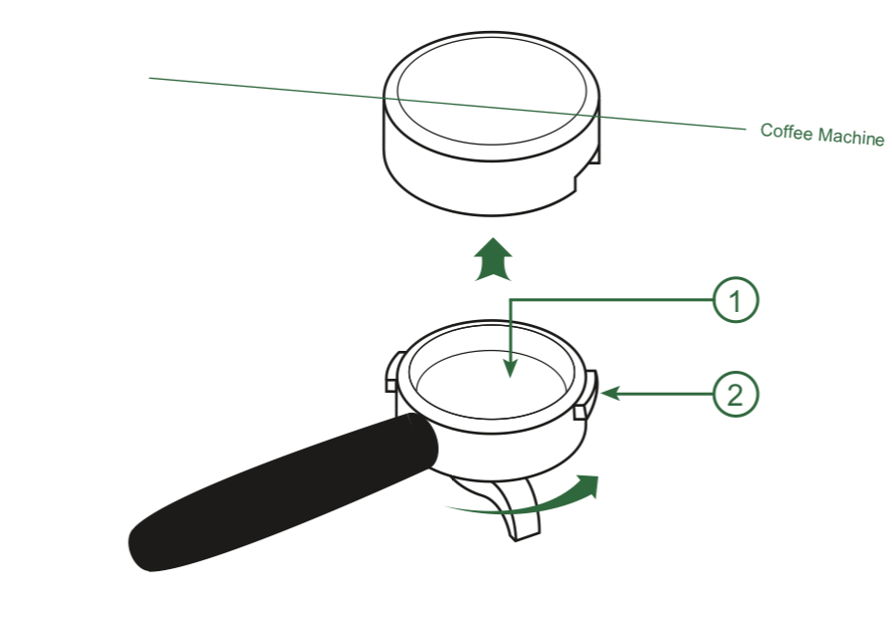
Auto Purging Instructions
1) This is done by inserting the blank filter into one of the filter holders.
2) Then put the filter holder into one of the groups as if making coffee.
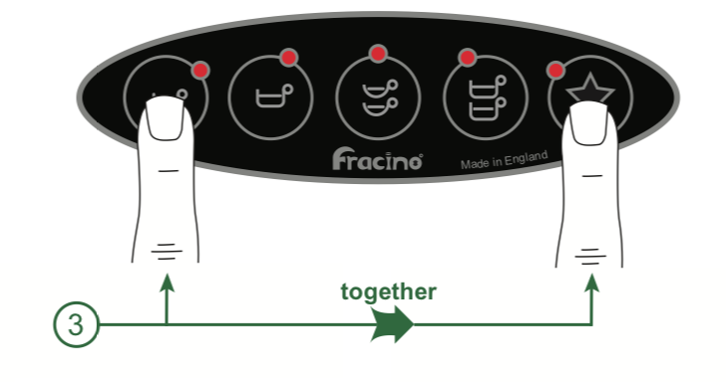
3) The 2-group Bambino is fitted with an automatic cleaning cycle which pulses the group on and off several times to speed up the cleaning process and helps to ensure a more thorough cleaning of the groups. The cleaning cycle is activated by pressing the espresso and star buttons at the same time, the group will pulse FIVE TIMES on and off then stop, repeat this for the 2nd group.
4) Remove the filter holder and empty out the dirty water. Put the filter holder back into the group and repeat the process until the water is clean and free of coffee particles from the group exhaust. When the filter holder is removed the water must run clear.

Programing of Preset Coffee Measures

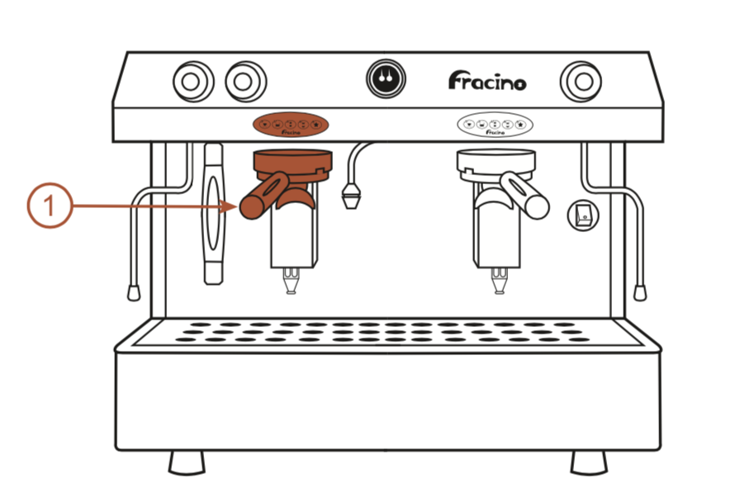

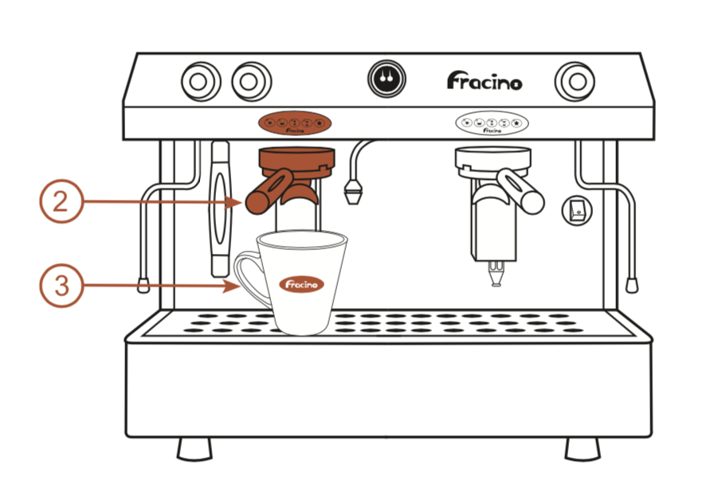
1) Machines with two or more groups are programmed on the left-hand group/touch pad. When the process is completed the settings will be stored for all groups. Any groups to the right can be programmed independently by following the same procedure.

2) Put one shot of coffee into a single filter holder and fit the holder into the left-hand group as shown at the start of this section.
3) Put the espresso cup under the beak.
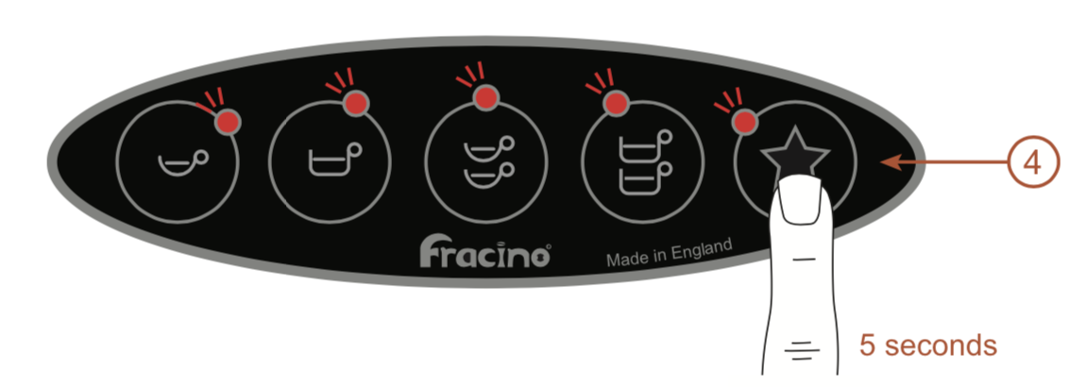
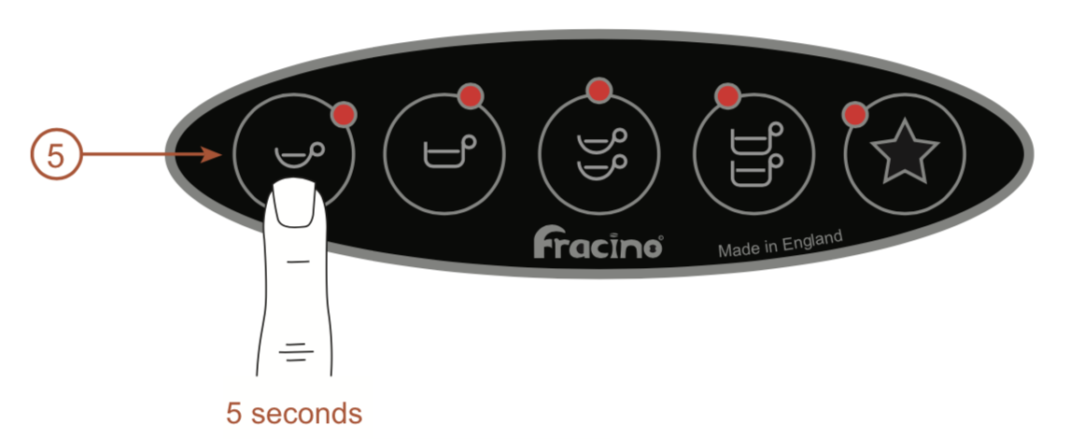
4) Press the star button on the left-hand touch pad and hold for 5 seconds until the lights above the symbols start to flash. The machine is now in program mode.
5) Press the single espresso button within 5 seconds and allow the coffee to fill the cup to the required level. Press the button again to stop and store the setting.
Note: If the button is not pressed within 30 seconds the machine will revert back to the previous settings and you will need to repeat the programming again.
Repeat steps 1-5 for:
Single Coffee: use the single filter holder, one shot of coffee, an espresso, cappuccino of latte cup.
Double Espresso: use the double filter holder, two shots of coffee and two espresso cups.
Double Coffee: use the double filter holder, two shots of coffee, two espresso, cappuccino or latte cups.
Note: The espresso is usually programmed as a short shot of espresso, the coffee is usually programmed as a longer shot of espresso, used for cappuccino and latte.

